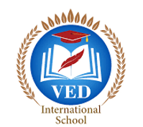

VED International School, Vadodara

**Date:- 01/07/2024**

**Announcement for Per-Primary and STD I to VIII**

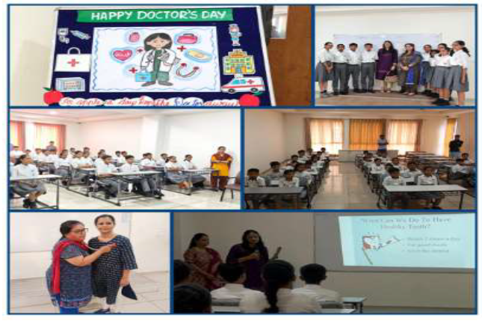

**Subject : Ved International School Celebrates Doctor's Day with Dental**

**Care Awareness**

On the occasion of **Doctor's Day, Ved International School invited Dr.**

**Tapasi Shah,** a renowned dental surgeon, to educate students on the importance

of dental care and healthy eating habits.

Dr. Tapasi Shah interacted with the students and shared valuable insights on:

* Proper brushing techniques
* Regular dental check-ups
* Avoiding sugary snacks
* Eating a balanced diet for healthy teeth and gums

The interactive session aimed to inculcate good oral hygiene practices and

promote healthy lifestyle choices among the students

Ved International School emphasizes the well-being of its students and

appreciates Dr.Tapasi Shah's expertise in inspiring young minds to prioritize

their dental health.

**Regards,**

**Ms.Upinder Kaur Ahluwalia**

**Principal**

**VED INTERNATIONAL SCHOOL**