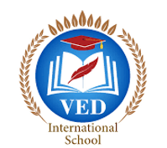

VED International School, Vadodara

**Date:- 14/06/2024**

**Announcement for STD I to VIII**

**Dear Parents,**

**Science Olympiad Foundations** every year organizes Olympiad exam for

different subjects. We have selected three major subjects for this year. Exam

name, Exam date and fees are mentioned below.

If your child is interested in appearing for any exam, fill the details mentioned

below and submit the fees within two days.

**Details of Exam:**

|  |  |  |  |
| --- | --- | --- | --- |
| Subject | Date | Date Fees  (Registration +  Books) | Total |
| IEO (International English  Olympiad) | 26th Sep | 150+75 | 225 |
| NSO (National Science  Olympiad) | 18th Oct | 150+75 | 225 |
| IMO (International  Mathematics Olympiad) | 22nd Oct | 150+75 | 225 |

**Note: Buying books is not compulsory, So pay accordingly.**

**Regards,**

**Ms.Upinder Kaur Ahluwalia**

**Principal**

**VED INTERNATIONAL SCHOOL**