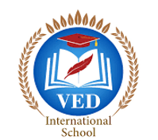

VED International School, Vadodara

**Date:- 15/06/2024**

**Announcement for Pre-Primary and Std I to VIII**

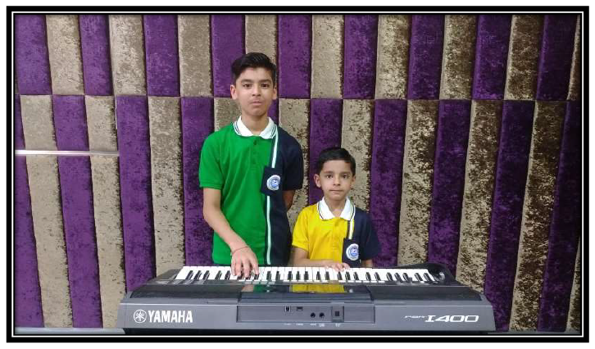

**Subject: Celebrating a Great Achievement at Ved International School.**

**Dear Parents,**

I am thrilled to share some wonderful news from Ved International School!

**Shivansh Sandip Agrawal**, a student of Std 3, and **Medhansh Sandip**

**Agrawal**, a student of Std 8, have been selected at the **\*international level for**

**their exceptional skills in keyboard play**. This achievement follows their

impressive qualification at the national level.

Their performances at the international level are scheduled for July 2024, and

we couldn't be prouder of their dedication and talent.

Let's congratulate Shivansh and Medhansh on this remarkable accomplishment!

**Regards,**

**Ms.Upinder Kaur Ahluwalia**

**Principal**

**VED INTERNATIONAL SCHOOL**