

VED International School, Vadodara

**Date:- 15/06/2024**

**Announcement for Pre-Primary and Std I to VIII**

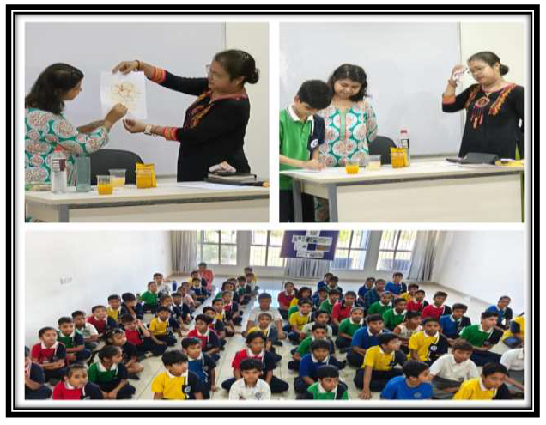

**Subject : Experiment based on Acid and Base.**

**Dear Parents,**

A fun and educational activity for students from standard 1 to 9 during science

time was conducted today.

This activity is engaging and uses ingredients that are commonly found at

home. This experiment demonstrates how substances change colour depending

on whether they are acidic or basic. This experiment is simple yet effective in

demonstrating basic principles of acidity and basicity using a natural indicator.

It encourages students to make observations, draw conclusions, and apply

scientific concepts in a hands-on way. Boosting our students can indeed

cultivate the scientists of the future!

**Regards,**

**Ms.Upinder Kaur Ahluwalia**

**Principal**

**VED INTERNATIONAL SCHOOL**