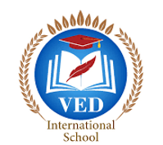

VED International School, Vadodara

**Date:- 17/04/2024**

**Announcement for Per-Primary and STD I to VIII**

Dear Parents,

Parents are guided to fill the forms given in Dairy/ Manual along with Medical

from (Signed and Stamped by Doctor) and submit by 13th April 2023.

**19/04/2024 will be last day for the submission.**

If not done, Parents to write a Diary note in the ward’s dairy with appropriate

reason.

**Regards,**

**Ms.Upinder Kaur Ahluwalia**

**Principal**

**VED INTERNATIONAL SCHOOL**