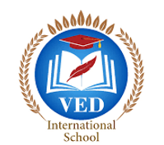

VED International School, Vadodara

**Date:- 18/06/2024**

**Announcement for Pre-Primary and Std I to VIII**

**Dear parents,**

Parents are guided to the forms given in Diary/ Manual along with Medical

form (Signed and Stamped by Doctor) and submit by 21st June 2024.

**Regards,**

**Ms.Upinder Kaur Ahluwalia**

**Principal**

**VED INTERNATIONAL SCHOOL**