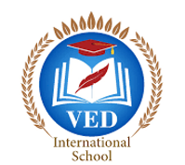

VED International School, Vadodara

**Date:- 19/06/2024**

**Announcement for Pre-Primary and Std I to VIII**

**NOTICE TO PARENTS**

**Dear Parents,**

We are excited to announce that Ved International School will be celebrating International Yoga Day and International Music Day on **Friday, 21st June 2024**.

We warmly invite all interested parents to join us for this special event.

**Event Details:**

**Date: 21st June 2024 (Friday)**

**Time for Parents: 8:30 AM**

**Venue: Ved International School Ground.**

**Important Information for Students:**

*Students will have a regular school day on Friday, 21st June 2024. Reporting time : 7:40 am

Students are required to wear their house uniform on this day.

Students and parents are requested to bring yoga mats for the yoga session.

Your participation will make the event more enjoyable and memorable for everyone.

**Regards,**

**Ms.Upinder Kaur Ahluwalia**

**Principal**

**VED INTERNATIONAL SCHOOL**