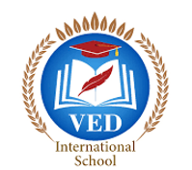

VED International School, Vadodara

**Date:- 21/06/2024**

**Announcement for Std I to VIII**

**Dear Parents,**

This is to inform that a parents teacher meeting will be conducted on 22nd June 2024 (Saturday) to review the overall performance of your ward for the month of June.

**Attendance of at least one parent is mandatory**

**Time: 9:00 am to 10:00am**

**looking forward to your active participant.**

**Regards,**

**Ms.Upinder Kaur Ahluwalia**

**Principal**

**VED INTERNATIONAL SCHOOL**