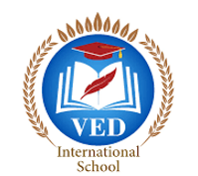

VED International School, Vadodara

**Date:- 21/06/2024**

**Announcement for Pre-Primary and Std I to VIII**

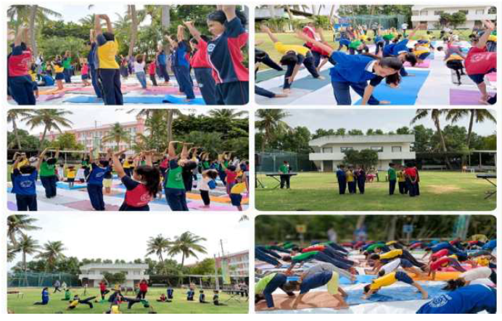

**Subject:** Successful Celebration of International Yoga Day and World Music Day at

Ved International School.

**Dear Parents,**

We are delighted to inform you that Ved International School today celebrated

International Yoga Day and World Music Day with great enthusiasm and success.

Both events were marked by active participation and showcased the talents and

dedication of our students from Nursery to std VIII.

Students engaged in various yoga postures and breathing exercises, guided by

experienced instructors, which helped them appreciate the importance of maintaining

a healthy lifestyle.

On World Music Day, our students showcased their musical talents through

performance. From classical to contemporary genres, the diversity of musical

expressions was truly remarkable, highlighting the musical prowess and creativity of

our students.

We are immensely proud of the dedication and enthusiasm shown by our students

throughout these celebrations.

We extend our heartfelt gratitude to all the students, and parents, who contributed to

making these event a grand success.

Looking forward to your continued support in future endeavours.

**Regards,**

**Ms.Upinder Kaur Ahluwalia**

**Principal**

**VED INTERNATIONAL SCHOOL**